POLICY

BRIEF
Ghana



WOMEN OF FAITH FOR A JUST ENERGY TRANSITION IN GHANA


Advancing Fossil Fuel Divestment and Gender-Responsive Renewable Energy Financing in Ghana's Western Region
Greenfaith Africa

Africa

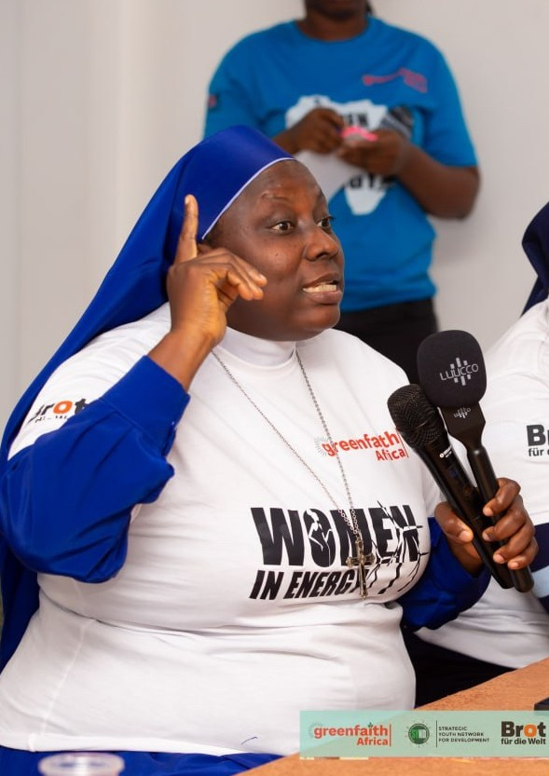


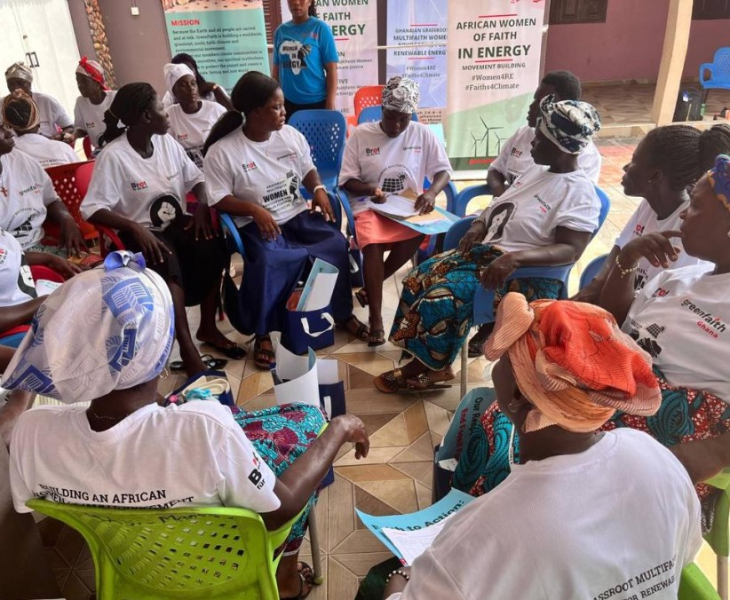
1 GreenFaith Ghana Policy Brief

Context:

Communities at the Frontlines of Ghana's Gas Expansion
The communities of Ngalechi and Anokyi in the Ellembelle District of Ghana's Western Region are among the communities directly affected by Ghana's expanding natural gas infrastructure, particularly the Atuabo Gas Processing Plant of the Ghana Gas Company located at Atuabo, a small coastal community, in the Nzemaland of the Western Region in Ghana and related gas-to-power developments under the national energy transition agenda.While these projects are often presented as pathways to economic growth and nationalenergy security, many grassroots women continue to experience increasing social,environmental, and economic burdens with limited participation in energy decision-making.
For generations, farming, fish processing, subsistence agriculture, and small-scale trading have sustained households across these coastal communities. Women have traditionally played central roles in food production, caregiving, environmental stewardship, and local economic resilience. However, land acquisition for fossil fuel infrastructure, ecological degradation, rising living costs, and declining access to productive resources are weakening these livelihood systems.
This policy brief is informed by community dialogue sessions convened with women of faithleaders, grassroots women, and caregivers from Ngalechi and Anokyi. Their testimonies reveal a widening disconnect between Ghana's national energy transition ambitions and the lived realities of vulnerable communities, especially women who bear the heaviest social costs of energy poverty and fossil fuel expansion.
For these women, energy is not merely a technical or economic issue. It is deeply connected to health, dignity, family wellbeing, justice, and the moral responsibility to protect creation and future generations.
The voices emerging from these communities call for a transition away from fossil fuel dependence toward people-centered renewable energy systems that prioritize equity, public health,livelihoods, and community ownership.

What Women Are Experiencing:
- Energy Poverty, Unpaid Care Work, and Economic Exclusion

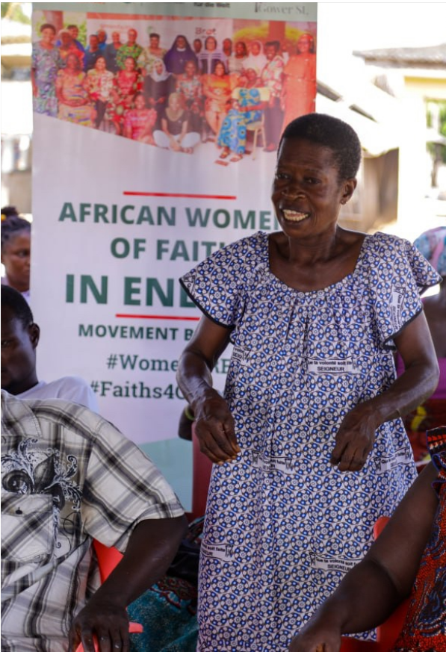
Although Ghana has made progress through the Renewable Energy Master P l a n a n d n a t i o n a l c l e a n c o o k i n g initiatives, many rural and low-income households in the Western Region still depend heavily on firewood and charcoal for cooking and heating. Women and girls re m a i n t h e p r i m a r y p rov i d e r s o f household energy and unpaid care work.
Women participating in the dialogue explained that they spend several hours daily searching for fuel wood, preparing meals under unsafe smoke conditions, caring for sick family members, and managing household responsibilities w i t h o u t a c c e s s t o re l i a b l e c l e a n energy alternatives.
“We hear about energy transition on the radio, but in our homes we still cook with smoke.
The burden is on women every day.”
Research in Ghana indicates that women spend significant hours on unpaid care work daily, much of which is directly linked to inadequate energy access. Limited access to affordable clean cooking technologies and reliable electricity reinforces time poverty, restricts women's economic opportunities, and contributes to intergenerational poverty.
For many women of faith, this burden is not only economic but moral. They believe a just energy system should restore dignity, protect health, and free women's time for education, leadership, enterprise, and community participation.
Without targeted financing and subsidies for clean cooking and decentralized renewable energy systems, vulnerable women remain excluded from the benefits of Ghana's energy transition.

- Health Impacts as a Human Dignity and Justice Concern
“Our mothers are suffering silently. Smoke has become part of daily life, but this should not be normal.”

Women across Ngalechi and Anokyi expressed concern over the growing health challenges associated with household air pollution and industrial activities linked to gas infrastructure.
The continued use of charcoal and firewood exposes women and children to smoke-related illnesses, including respiratory infections, eye diseases, cardiovascular complications, and pregnancy-related health risks. According to the World Health Organization, household air pollution remains a major contributor to preventable deaths globally.
Women described the painful reality of cooking in enclosed kitchens filled with smoke while also caring for children and elderly relatives.

A community faith leader shared “Our mothers are suffering silently. Smoke has become part of daily life, but this should not be normal.”
Participants also raised concerns about persistent industrial noise, gas flaring activities, and anxiety linked to expanding infrastructure operations within nearby communities.
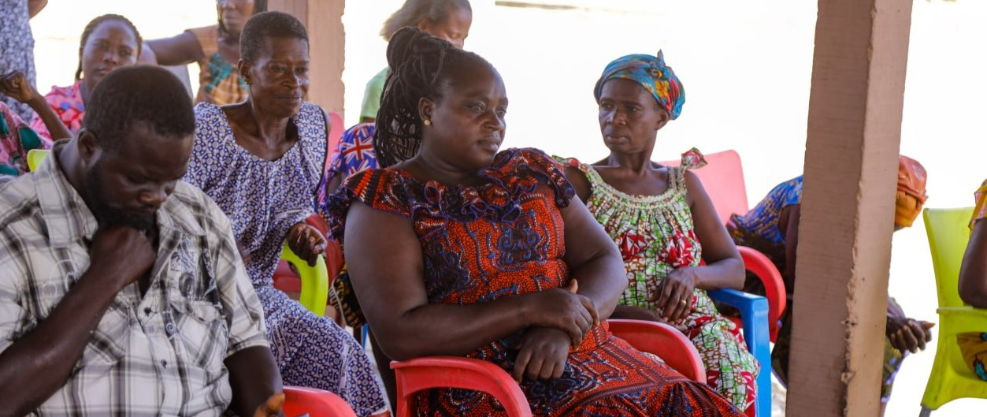
Women emphasized that access to clean energy should be recognized as a public health and human dignity issue rather than only an energy sector concern.

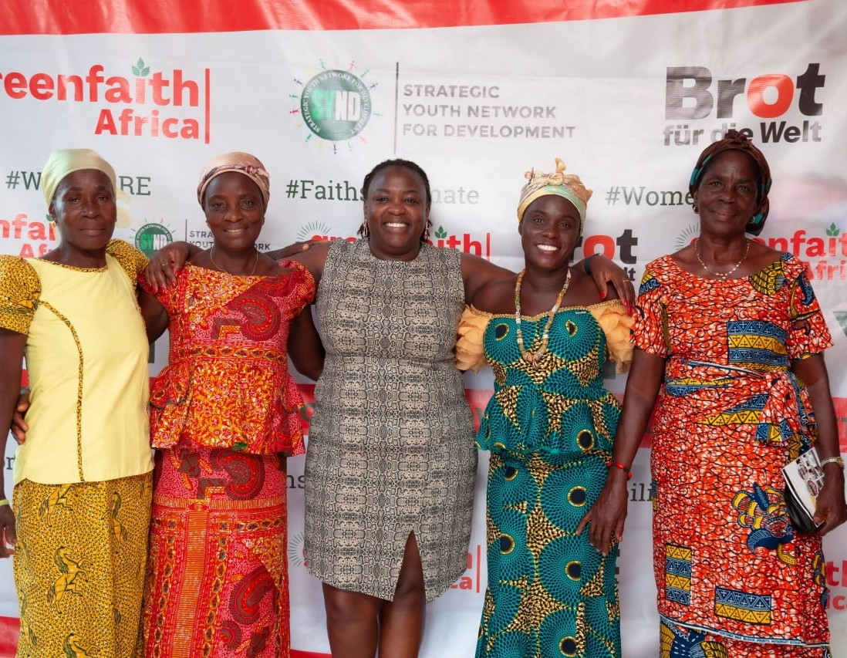

Women reported that fossil fuel expansion has contributed to the loss of fertile lands, declining fish stocks, restricted access to traditional livelihood areas, and increased environmental stress within local ecosystems.
Community members explained that some lands previously used for farming and gathering are no longer accessible due to industrial activities and land acquisitions associated with gas infrastructure expansion.
One participant explained: “The land that fed our families is gradually disappearing, and women are carrying the hardship.”
The environmental impacts are compounded by increasing inflation, reduced local economic opportunities, and limited benefit-sharing mechanisms for host communities.
Women also expressed concern that young people are increasingly migrating from the area in search of jobs, leaving women with expanded caregiving responsibilities and weakened social support systems.
Some women disclosed that financial hardship and declining household income are contributing to rising domestic tensions and gender-based vulnerabilities within homes.
Despite carrying the greatest social burden of energy poverty and environmental degradation,women remain significantly under represented in renewable energy investments, policy discussions, energy procurement systems, and green job opportunities.
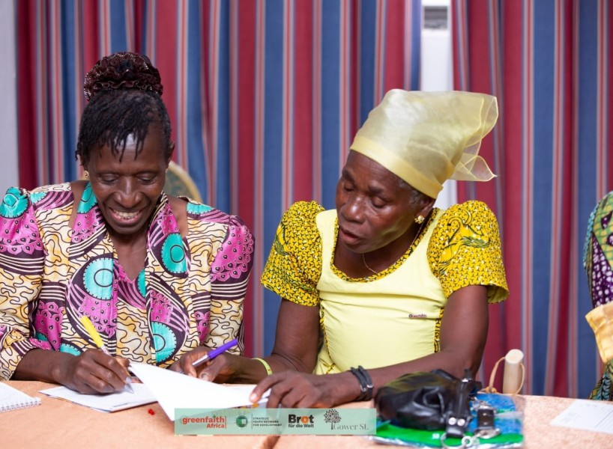
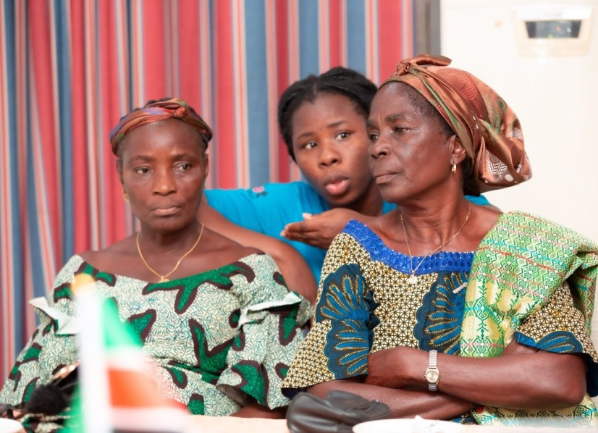
Without deliberate gender-responsive policies, Ghana's energy transition risks modernizing infrastructure while preserving structural inequalities.

4.Key Policy Gaps Identified by Grassroots Women

Women of faith and community participants identified several major policy and implementation gaps:

National energy planning continues to prioritize large-scale infrastructure expansion without adequately integrating gender justice and unpaid care reduction indicators.
1
2
Clean cooking initiatives remain underfunded and inaccessible for m a n y l ow - i n c o m e a n d r u ra l women.

Renewable energy financing mechanisms are not sufficiently reaching grassroots women, women-led enterprises, and faith-based community
3
initiatives.
Women remain under represented in renewable energy governance, procurement systems, technical training, and green employment
pathways.
4

Community consultation processes on fossil fuel projects remain weak, irregular, and insufficiently inclusive of women's voices.
5
Ghana's climate and energy reporting frameworks inadequately account for unpaid care work and the disproportionate social burdens carried by women.

Public financing and international investments continue to support fossil fuel infrastructure expansion while community-scale renewable energy systems remain underfunded.
6
7

Faith Perspectives:

Energy Transition as a Moral and Justice Imperative
For women of faith across Ghana, the transition from fossil fuels to renewable energy is fundamentally a moral responsibility grounded in justice, stewardship, and human dignity.
Faith teachings across Christian and Muslim communities emphasize the sacred responsibility to care for creation, protect vulnerable populations, and ensure fairness across generations.
Women participants highlighted three core moral principles:

STEWARDSHIP
Protecting land, water, air, forests, and biodiversity for present and future generations.
JUSTICE
Ensuring that the burdens of pollution, energy poverty, and climate impacts do not fall disproportionately on poor women and vulnerable communities.

DIGNITY
Safeguarding women's health, time, livelihoods, and opportunities through equitable access to clean energy and economic participation.
Women of faith stressed that energy transition cannot only be measured in megawatts or infrastructure expansion. A truly just transition must improve the daily lives of ordinary people, especially women at the grassroots level.
As one faith participant noted:
“An energy transition that leaves women behind cannot be called just.”

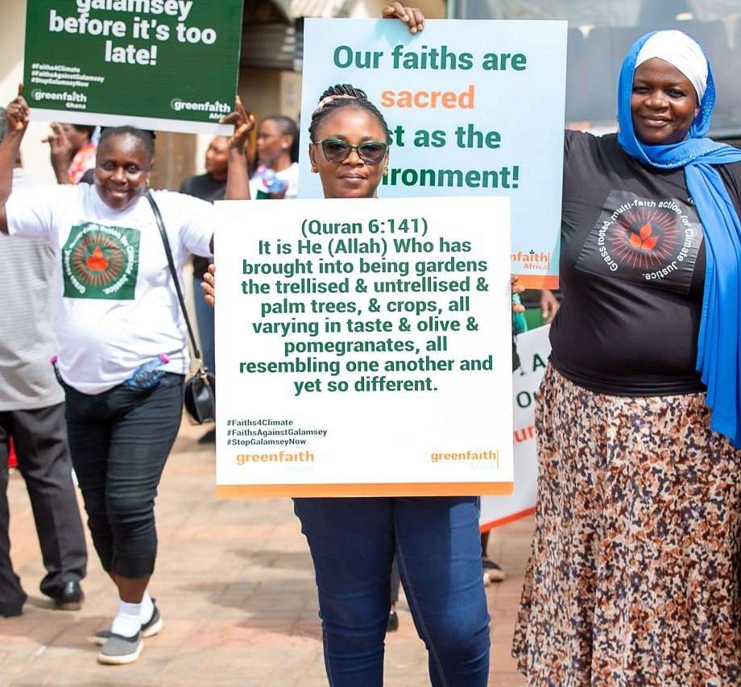
Faith communities therefore call for a transition that moves Ghana away from fossil fuel dependence toward decentralized, affordable, community-owned renewable energy systems that prioritize human well being over extractive profit.

5. What Women of Faith Are Calling For
As women of faith from Ghana's Western Region and members of broader African women of faith networks, we respectfully call on government institutions, financial actors, development partners,and faith leaders to pursue a gender-responsive and justice-centered energy transition.



PROGRESSIVE DIVESTMENT FROM FOSSIL FUEL EXPANSION
Public and private financial institutions should progressively redirect investments away from new fossil fuel infrastructure toward renewable energy systems that benefit communities directly.
INCREASED FINANCING FOR COMMUNITY-BASED RENEWABLE ENERGY
Scale up financing for solar energy, clean cooking technologies, mini-grids, and locally owned renewable energy enterprises led by women and grassroots communities.
GENDER-RESPONSIVE CLEAN COOKING POLICIES
Expand subsidies, results-based financing, and targeted support for vulnerable women to access affordable clean cooking solutions.
WOMEN'S PARTICIPATION IN RENEWABLE ENERGY GOVERNANCE
Establish quotas, procurement incentives, leadership pathways, and technical training opportunities for women within renewable energy and green economy sectors.
RECOGNITION OF UNPAID CARE WORK IN ENERGY POLICY
Integrate unpaid care reduction indicators into national energy planning, climate reporting, and budgeting frameworks.

STRONGER COMMUNITY CONSULTATION AND ACCOUNTABILITY
Ensure meaningful participation of women, faith leaders, and grassroots communities in all energy-related consultations and environmental decision-making processes.
CLIMATE FINANCE THAT REACHES COMMUNITIES
Development partners and climate finance institutions should prioritize direct funding mechanisms that empower local women-led and faith-based climate initiatives.

A just energy future for Ghana must not only reduce emissions; it must also protect livelihoods,restore dignity, recover women's time, strengthen public health, and build resilient local economies.

6. Intended Audience
This policy brief is intended for:
·Ministry of Energy and Green Transition
·Environmental Protection Agency
·Public Utilities Regulatory Commission
·Petroleum Commission
·Faith institutions and interfaith networks
·Development partners and climate finance institutions
·Renewable energy investors and private sector actors
·Civil society organizations and women-led movements
·Regional and international climate policy actors
METHOD NOTE
This policy brief draws from participatory dialogue sessions conducted with women of faith, caregivers, farmers, fish processors, youth representatives, and grassroots community members in Ngalechi and Anokyi in the Ellembelle District of Ghana's Western Region.
The discussions explored lived experiences relating to fossil fuel expansion, energy poverty, unpaid care work, environmental change, and renewable energy access.
The draft brief was reviewed through consultations with members of African women of faith networks and climate justice advocates to ensure that the recommendations reflect grassroots realities,community ownership, and gender-responsive policy priorities.
REFERENCES
- Government of Ghana. (2019). Renewable energy master plan. Ministry of Energy. Ministry of Energy and Green Transition Ghana
- Government of Ghana. (2021). Ghana's updated nationally determined contribution under the Paris Agreement (2020–2030). Ministry of Environment, Science, Technology and Innovation. Ministry of Environment Science Technology and Innovation Ghana
- International Energy Agency. (2023). Africa energy outlook 2023. International Energy Agency Africa Energy Outlook
- Kumi, R. A. K., & Owusu, E. (2018). Monetary valuation of unpaid care work and experiences of women in the Upper East Region of Ghana. University for Development Studies.
- Republic of Ghana. (2011). Renewable Energy Act, 2011 (Act 832). Government of Ghana. Ghana Legal Information Institute
- Republic of Ghana. (2020). Renewable Energy (Amendment) Act, 2020 (Act 1045). Government of Ghana. Ghana Legal Information Institute Renewable Energy Amendment Act
- UN Women. (2022). Gender, energy, and climate policy in Africa: Strengthening women's inclusion in just energy transitions. UN Women Africa
- World Health Organization. (2023). Household air pollution and health. World Health Organization Household Air Pollution and Health

